3-2 :-

RETRIEVING DATA IN PL/SQL :

USING THE INTO CLAUSE :-

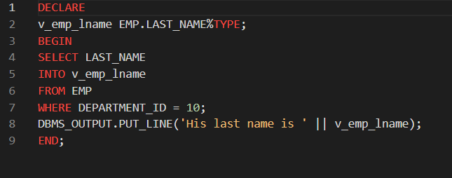



RETRIEVING DATA IN PL/SQL :-

CREATE A TABLE :-

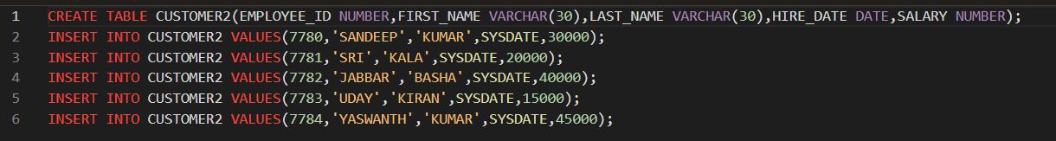

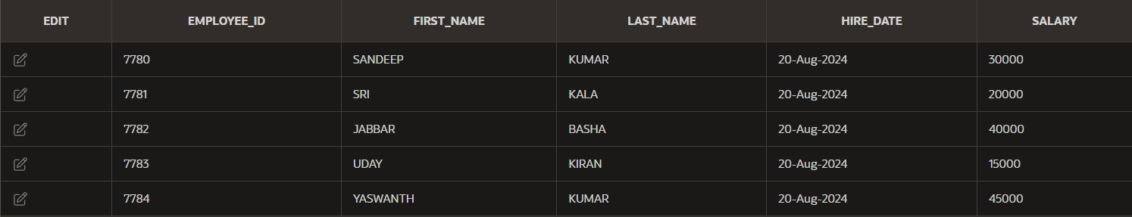

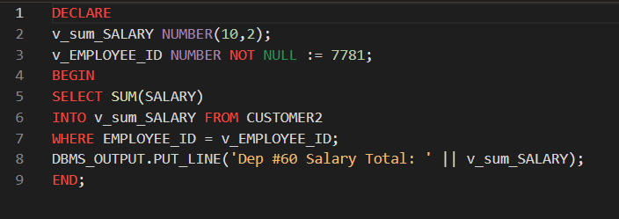



RETRIEVING DATA IN PL/SQL EMBEDDED RULE :-

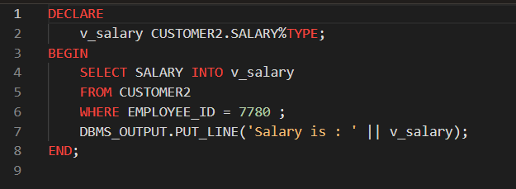



3-3 :-

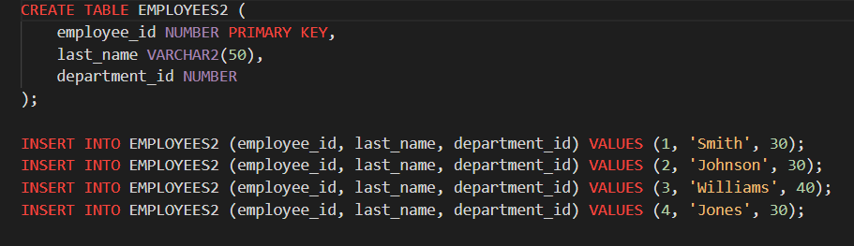

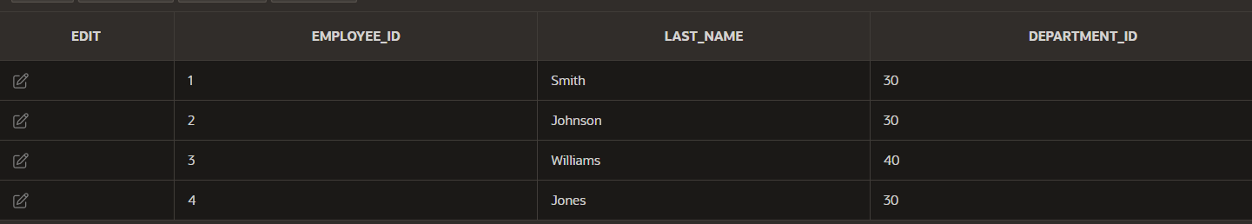

FETCHING THE VALUES FROM THE CURSOR :-

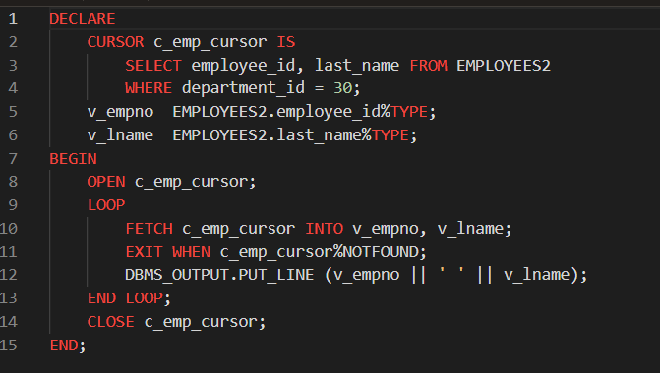

OUTPUT :-



FETCHING THE VALUES INTO A RECORD :-

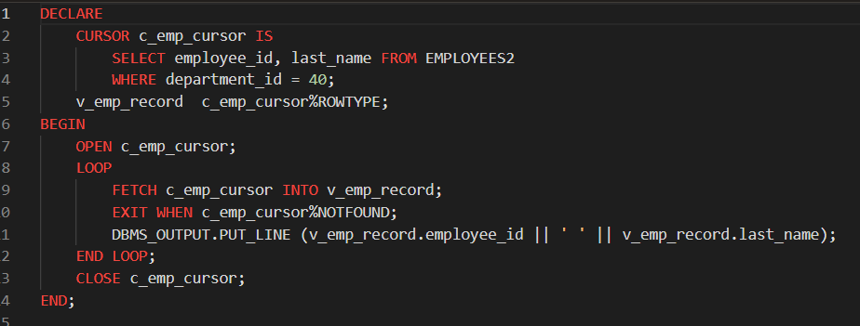

OUTPUT :-



USING %ROWCOUNT AND %NOTFOUND ATTRIBUTES :-

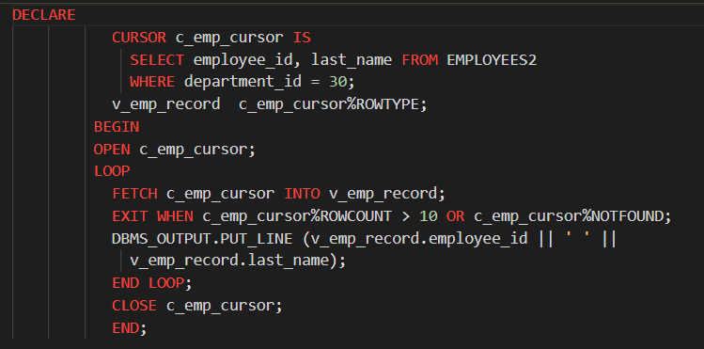

OUTPUT :-

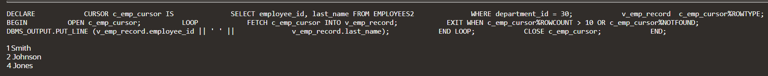

USING A CURSOR FOR LOOP WITH SUBQUERIES :-

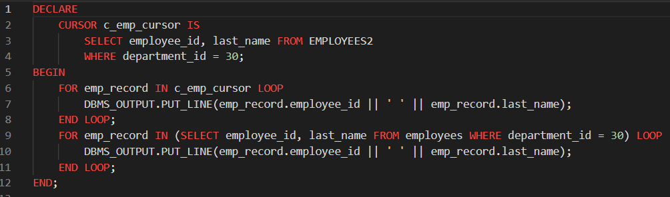

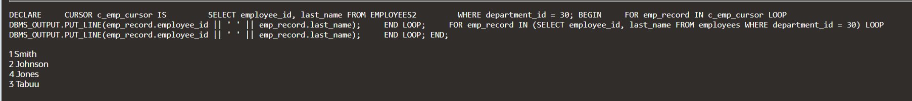

CREATING A TABLE AND INSERTING THE 10 VALUES :-

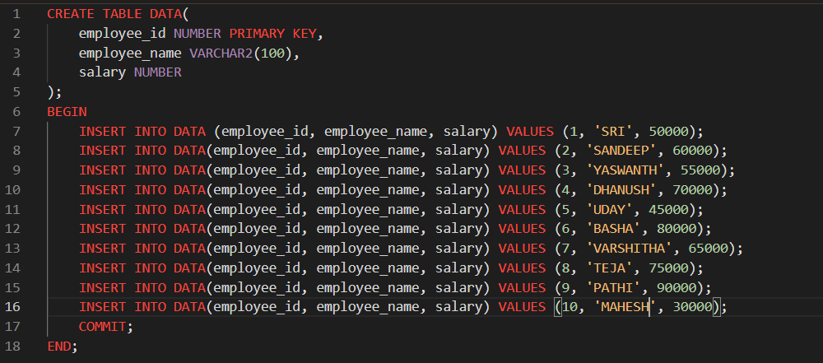

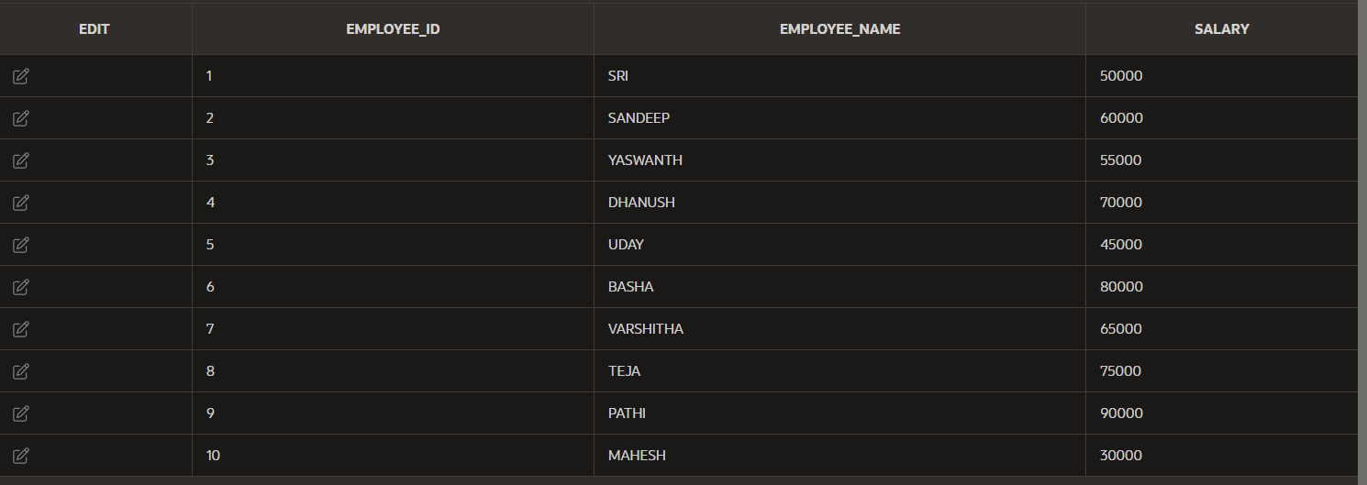

WITHOUT USING CURSOR ASCENDING ORDER :-

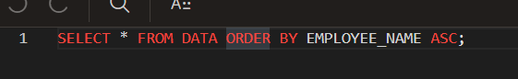

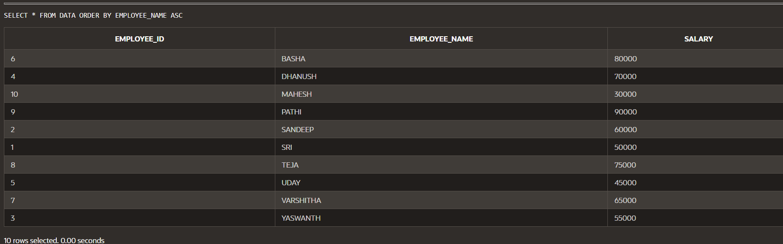

USING CURSOR :-

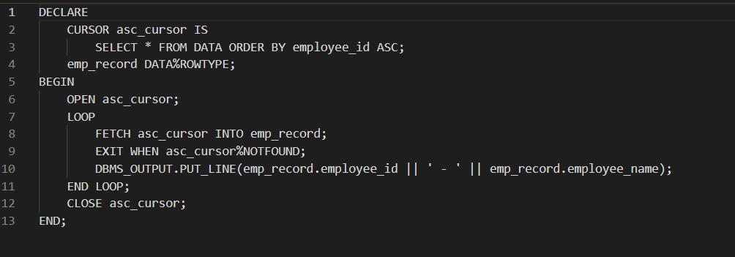

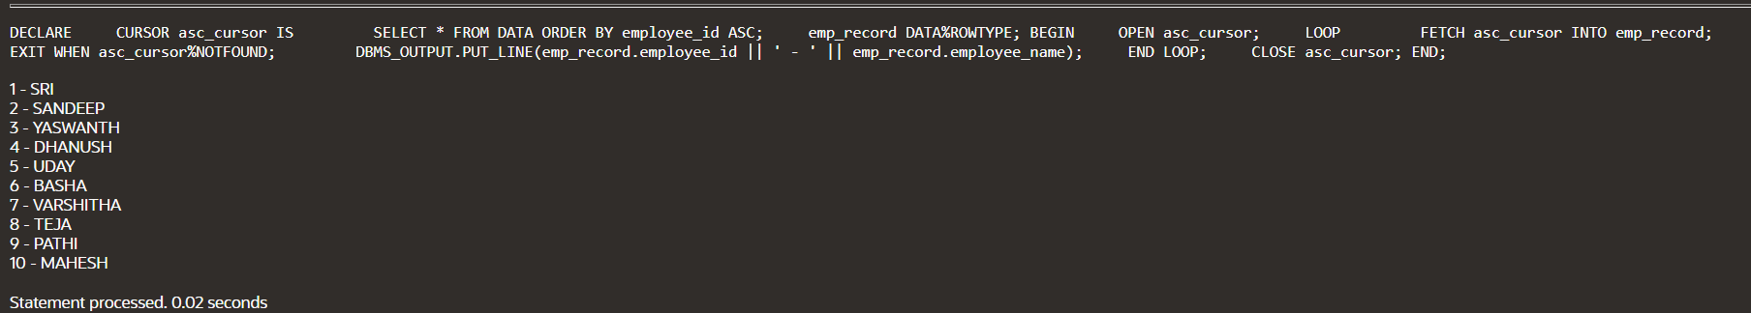

WITHOUT USING CURSOR DESCENDING ORDER :-

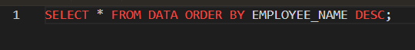

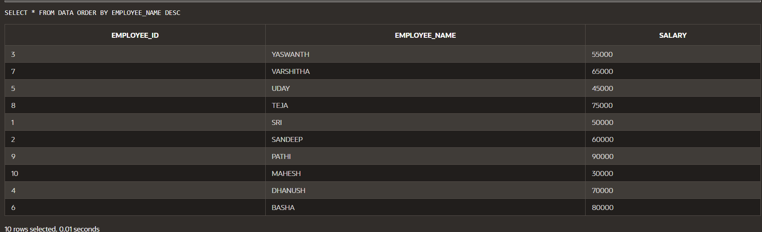

USING CURSOR :-

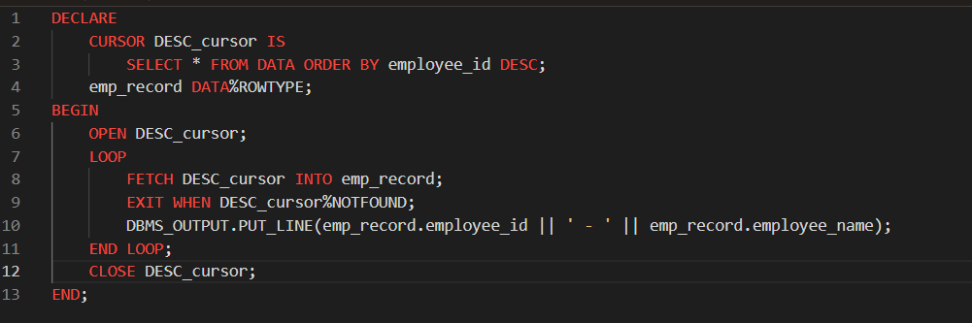

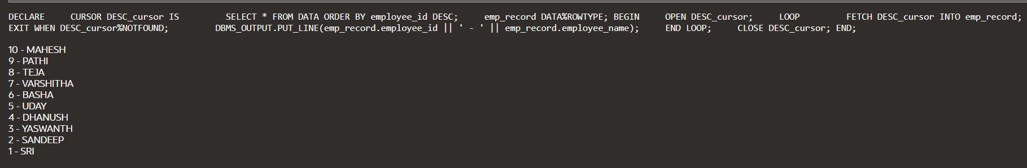

GO TO :-

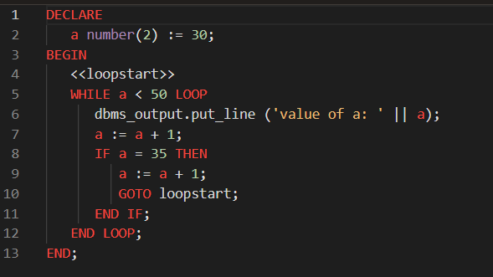

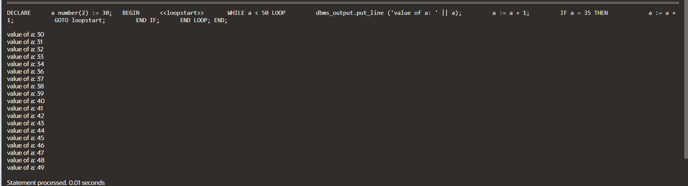

PL/SQL BLOCK TO HANDLE THE EXCEPTION WHEN A DIVISION BY ZERO OCCURS :-

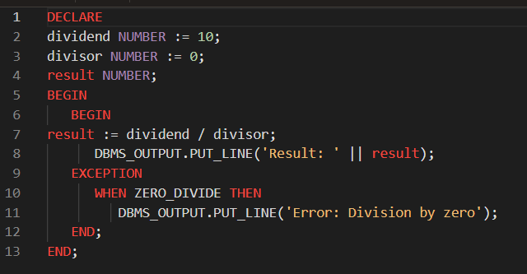

OUTPUT :-



HANDLE THE NO_DATA_FOUND EXCEPTION WHEN RETRIEVING A ROW FROM A TABLE AND NO MATCHING RECORD IS FOUND :-

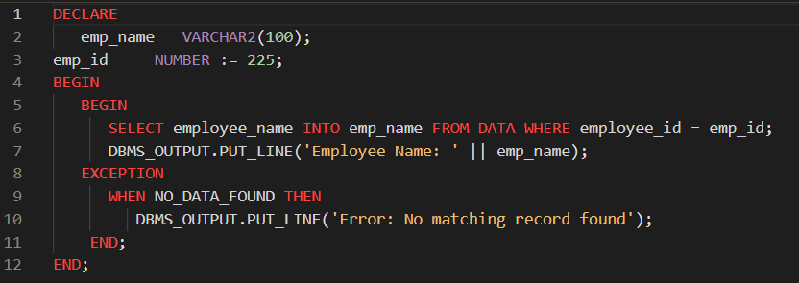

OUTPUT :-



HANDLE THE TOO_MANY_ROWS EXCEPTION WHEN RETRIEVING MULTIPLE ROWS INSTEAD OF A SINGLE ROW FROM A TABLE :-

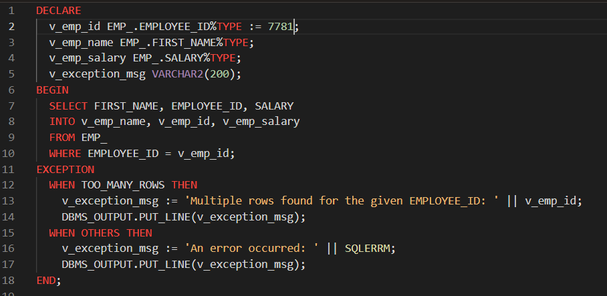



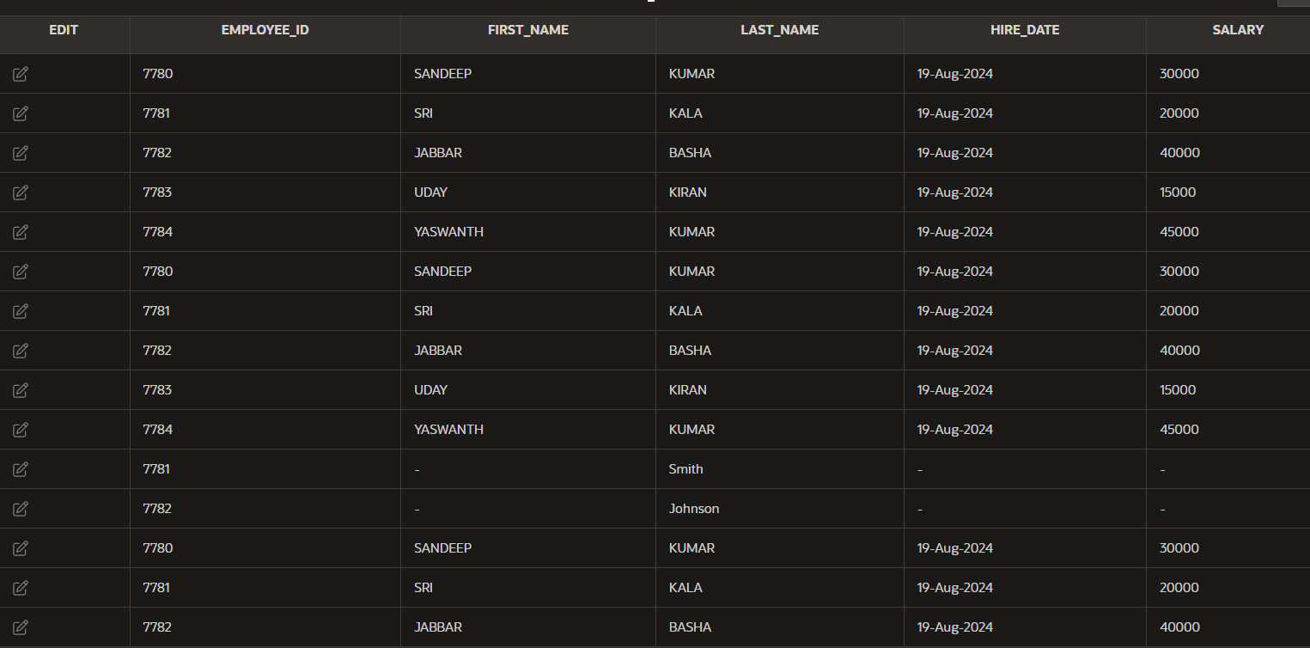

HANDLE THE INVALID_NUMBER EXCEPTION WHEN CONVERTING A NON-NUMERIC VALUE TO A NUMBER :-

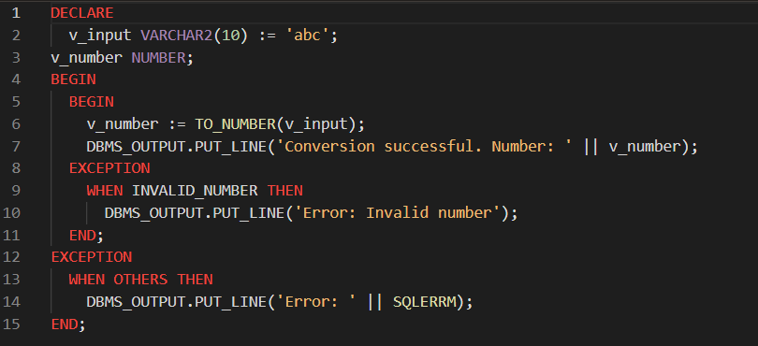



HANDLE THE DUP_VAL_ON_INDEX EXCEPTION WHEN INSERTING A DUPLICATE VALUE INTO A TABLE WITH A UNIQUE CONSTRAINT :-

